Exclusively for exchange students
and foreigners living in Japan!

Yurihama, Tottori Prefecture: The Hometown of Ground Golf

Sunday, October 2nd, 2016!
★2016 Yurihama International Ground Golf Open★

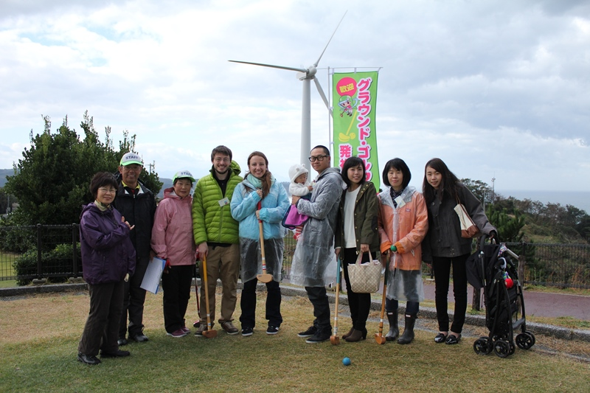
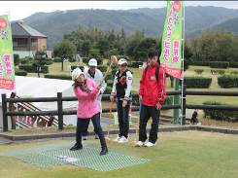

The Birthplace of Ground Golf: Yurihama, Tottori Prefecture
Ground golf was developed in the town of Yurihama (formerly Tomari Village) in Japan’s Tottori Prefecture in 1982. With simple rules that allow anyone to enjoy the game, ground golf’s popularity has spread throughout Japan, as well as abroad.
The Hometown Park of Ground Golf: Shiokaze no Oka Tomari
The hometown park of ground golf, Shiokaze no Oka Tomari, is a ground golf course specifically designed for the sport and has been approved by the Japan Ground Golf Association. With a view looking out across the ocean, it is an ideal location with a total of 3 different courses and a multi-purpose lawn area. Various ground golf tournaments are held at Shiokaze no Oka Tomari throughout the year, bringing players together from both inside and outside of Tottori Prefecture.
Access:
Tokyo (Haneda Airport) ⇒ Tottori Conan Airport (Approx. 1 hr 20 min) ⇒ Train/Bus (Approx. 1 hr)
Tokyo (Haneda Airport) ⇒ Yonago Kitarō Airport (Approx. 1 hr 25 min)⇒ Train/Bus (Approx. 1 hr)
Kansai International Airport ⇒ Kobe/Kansai Int’l Airport Bay Shuttle ⇒ Kobe Airport
⇒Yonago Kitarō Airport (Approx. 1 hr 30 min) ⇒Train/Bus (Approx. 1 hr)
Kansai International Airport ⇒ Train/Bus (Approx. 5 hrs)
Okayama Airport ⇒ Train/Bus (Approx. 4 hrs 30 min)
Hiroshima Airport⇒ Train/Bus (Approx. 6 hrs 30 min)
――― Event Details ―――
2016 Yurihama International Ground Golf Open
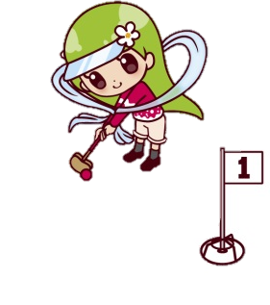
Come make new friends at the birthplace of ground golf!
WHEN: Sunday, October 2nd, 2016
WHERE: The Hometown Park of Ground Golf
Shiokaze no Oka Tomari
1313 Tomari, Yurihama-cho, Tohaku-gun, Tottori-ken
Participants: 384 Maximum Capacity
※In the event applicants exceed the number of slots available, foreign applicants shall be given preference and players applying from within Japan shall be selected via lottery.
Entry Fee: \1,000 per person (A bento lunchbox will be provided by the event organizer)
★Perks of Participating ・Everyone will receive the following 3 gifts!! ★
1. 1 Suimeiso Hotel Onsen Voucher
2. 1 Box of Hawaiian Macadamia Chocolates
3. 1 Tōgō Yuasis Ryuhōkaku Spa Resort Entry Voucher
Schedule: 9:00am – 9:30am Registration and Ground Golf Lessons & Practice
10:00am – 10:40am Opening Ceremony
11:30am – 3:30pm Gameplay
4:00pm – 4:30pm Awards & Closing Ceremony
Deadline to Enter: Friday, August 26th. 2016
Meeting Spots: Tottori Station, Central Tottori General Office (in front of TPIEF’s Kurayoshi office), Yonago Station, or Shiokaze no Oka Tomari (Free shuttle bus service available. Details provided separately.)
Rules of Play: Gameplay will follow the rules established by the Japan Ground Golf Association.
Gameplay: 1. Players will complete 2 rounds of 8 holes.
2. Gameplay will be individual. Those assigned to Group A will use the inside and multi-purpose area courses, while those assigned to Group B will use the outside and cape courses during gameplay. The final ranking will be determined for each group based on the player’s total number of strokes.
Other: 1. Clubs and balls used must be equipment approved by the Japan Ground Golf Association.
※Gear and markers will be available for use at no charge.
2. Subject to change in the event of bad weather.
3. All participants will receive GG memorabilia and a certificate of participation.
★ Please direct any inquiries and submit applications to:
International GG Open Executive Committee
〒682-0723 Tottori-ken, Tōhaku-gun, Yurihama-chō, Hisadome 19-1
E-mail: groundgolf@yurihama.jp TEL: 0858-35-5368 FAX: 0858-35-5387

